|  |  |
| --- | --- |
| cetlogo ***CHEMICAL ENGINEERING TRANSACTIONS***  ***VOL., 2024*** | A publication of  aidiclogo_grande |
| The Italian Association  of Chemical Engineering  Online at www.cetjournal.it |
| Guest Editors: Marco Bravi, Antonio Marzocchella, Giuseppe Caputo  Copyright © 2024, AIDIC Servizi S.r.l. **ISBN** 979-12-81206-10-6; **ISSN** 2283-9216 | |

Smart-delivery systems in Nano-Enabled Agriculture.  
The current state-of-the-art on nanohydroxyapatite

Laura Pilotto1,2, Luca Marchiol1\*, Guido Fellet1

1 DI4A – Department of Agri-Food, Environmental and Animal Sciences, University of Udine (I)

2 DSV – Department of Life Sciences, University of Udine (I)

[luca.marchiol@uniud.it](mailto:luca.marchiol@uniud.it)

The development of nanotechnologies in the last 25 years has considerably improved, even revolutionized, many technology and industry sectors: information technology, medicine, transportation, energy, environmental science, and everyday products, as well. Nano-enabled agriculture (NEA) describes the application of nanotechnology in agriculture to improve the performance of agrochemicals. NEA mainly focuses on improving the agrochemical uptake efficiency by crops, enhancing plant growth and food safety, and mitigating the environmental impacts of agriculture. However, nanotechnology applications in the agricultural chain are still marginal and have not yet made it to the market in comparison with other industrial sectors. Compared to other productive sectors, the main reason for the slow development of the NAE is due to the specific peculiarities of agriculture.

The use of renewable materials deriving from plant and animal waste biomass to produce nanosized delivery systems in NEA represents a crucial step towards the fulfillment of a circular economy. A paradigmatic example concerns the valorization of hydroxyapatite (nHAP). The paper provides updates on the use of nHAP for sustainable crop phosphorus fertilization and the development of nanohybrids to provide other macro-nutrients loaded on the nHAP structure.

* 1. Introduction

Agriculture produces food and other fundamental goods for society such as biofuels, fibers, and biomolecules for both medicine and industrial uses, having also significant interactions with the environment and society (Springmann et al. 2018). The primary sector contributes 1.3%, 8.8%, and 25% to the global gross domestic production (GDP) of high-income, middle-income, and low-income countries respectively (World Bank, 2023). Sustainable and reliable agriculture is Goal 2 "Zero hunger", among the 17 project aims of the Sustainable Development Goals promoted by the United Nations (United Nations, 2018).

The Green Revolution, which occurred from the 1930s to the 1960s, led to a significant increase in global crop production. According to a study by Gollin et al. (2021), crop production increased by 44% from 1965 to 2010. This was made possible by intensive genetic improvements in the most cultivated crops, as well as the widespread construction of irrigation systems. Additionally, the availability of synthetic fertilizers, pesticides, herbicides, and fungicides also contributed to this increase in crop production. However current farming practices, excessive water use, and fossil fuels have made agriculture unsustainable. Indeed, agriculture and associated land use contribute to approximately 20% of global greenhouse gas emissions (FAO, 2021). However, this sector faces the critical challenge of meeting the food demands of an ever-expanding global population, projected to reach around 9.6 billion by 2050. (OECD/FAO. 2020). This analysis highlights the urgent need for scientific and policy interventions to address the global issue of food security (Behl et al., 2022). Sustainable feeding of the global population requires transformative changes in the food system. Technological innovations are a key driver of this change.

In the context of field crop management, Nutrient Use Efficiency (NUE) measures how well plants can utilize the available mineral nutrients. While this can be calculated by simply looking at the crop yield per unit input of fertilizers, it is a result of two things: (i) the plant's ability to obtain nutrients from the soil, and (ii) their transport and allocation in different parts of the plants. (Hawkesford et al., 2014).

The current fertilization practices are poorly efficient. Considering the most important plants’ nutrients, nitrogen (N) and phosphorus (P), the NUE of the most important N- and P-fertilizers is 30-55% and 18-20%, respectively.

And if we consider the efficiency for the entire life of fertilizers, from industrial synthesis to their allocation, for example, within corn grains, the conversion efficiencies for N and P contained in urea and mono ammonium phosphate may not exceed 10% (Urso and Gilbertson, 2018). In other words, only a tiny fraction of such elements enters plants (Smith et al., 2018). The rest of N is lost, causing negative impacts on freshwater and groundwater quality, human health risks, and climate change [Kanter et al., 2018]. That also occurs in the case of P but with different global implications. While the Haber-Bosch process ensures the N supply to the fertilizer industry, P fertilizer production depends on the availability of phosphate rocks extracted from non-renewable geological P deposits, an increasingly limited resource [Alewell et al., 2020]. The recovery of P from thermally treated animal bones has been suggested recently as one of the economically viable and sustainable solutions to overcome the P-crisis [Ahmed et al., 2021].

* 1. Nano-Enabled Agriculture

Returning to the expected innovations, entering nanotechnologies into the primary sector could be a turning point and help overcome critical agricultural issues. It is believed that nanomaterials could play an essential role in the future of agriculture. Properly designed nanomaterials could enhance plant tolerance to environmental stresses, improve crop yield, and deliver more efficient plant protection products. In addition to ensuring adequate production levels, it is expected to reduce the environmental pressure of food production and improve agriculture resilience. While research explores new materials and operating strategies, the term "Nano-Enabled Agriculture" has been coined (Kah et al., 2019).

Nanotechnology has significantly contributed to various productive sectors such as electronics, information technology, medical and healthcare, energy, mobility, environmental remediation, and everyday commercial products. However, this has not been the case in agriculture, where research on this subject is relatively recent. Figure 1 shows the outcomes of a recent literature survey conducted on Scopus (as of April 22, 2023), illustrating the rapid quantitative and temporal expansion of scientific research concerning "Nanotechnologies." This growth trend notably accelerated during the late 1990s.

Additionally, the graph includes information on the query "Nanotechnology in Agriculture" and “Nano-Enabled Agriculture.

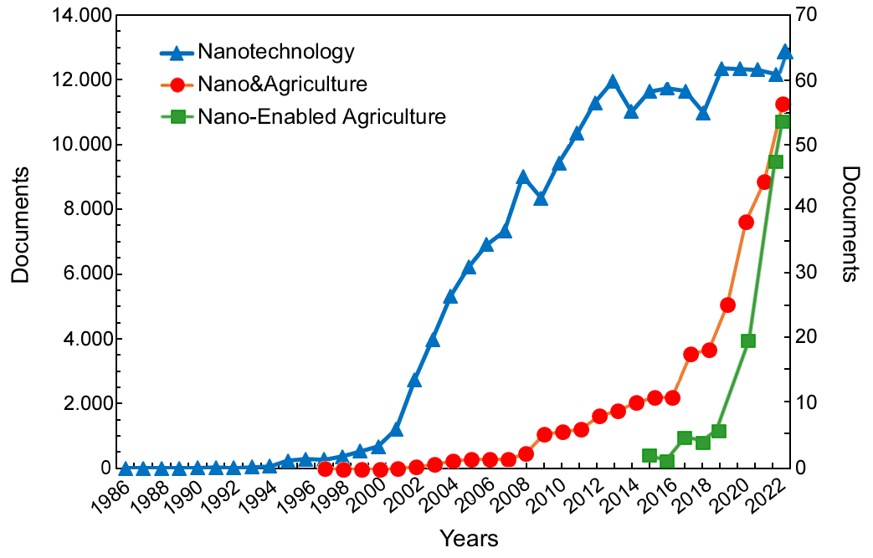

Figure 1: Number of published papers on Nanotechnology (blue triangles), number of documents focused on Nanotechnology in Agriculture (red circles), and on Nano-Enabled Agriculture (green squares).

The research on implementing nanotechnologies in agriculture is dramatically lagging other sectors. That is paradoxical, given that it urgently needs innovations to make production processes efficient and more sustainable. However, after isolating the data of "Nanotech in Agriculture" with a more suitable scale, we can observe a significant increase in papers in this area with a delay of about ten years.

The primary sector has distinct characteristics that set it apart from other productive sectors. Consider, for example, the progression of research aimed at integrating nanotechnologies into the fields of medicine and agriculture: in the medical field, research has mainly focused on humans, while in agriculture, there are approximately 7,000 species of edible plants, with about 25-30 crop species being the most cultivated. Moreover, the interaction between nanomaterials and plant morphology and physiology varies among plant species; hence, the results observed in one crop species may not apply to another (Mullen, 2019). A second point concerns the production scalability and costs of nanomaterials for agriculture. Innovations often start with the most expensive products with limited usefulness. In medical applications, a higher production cost may be acceptable, but in agriculture, agrochemicals need to be sold at lower prices (Mullen, 2019).

Since research and testing have only recently begun, more time is needed to develop sufficient knowledge to determine safety and precautionary margins.

* 1. Nano-hydroxyapatite. Sources and potential applications in agriculture.

Current research is exploring the potential of intelligent nanostructures to accurately release and distribute nutrients, agrochemicals, and biomolecules. These nanomaterials can intelligently regulate the duration of nutrient release based on the plant's developmental stages, reducing any negative environmental impacts (Usman et al., 2020).

The soil on Earth usually contains 0.10% of P and 3.4% of Ca. When the oxides of these elements combine, they form ortho- (PO4)3, pyro- (P2O7)4, and poly- ((PO3)n × n) phosphates, which make up more than 50% of soil P (Dorozhkin and Epple, 2002). Natural orthophosphates are identified by deposits of fluorapatite and phosphorites, which have a high concentration of P that makes them economically viable for the production of the most used P fertilizers in agriculture such as ammonium monophosphate (MAP, NH3H2PO4), diammonium phosphate (DAP, (NH3)2H2PO4), and triple superphosphate (TSP, Ca(H2PO4)).

It is important to note that global agricultural production relies heavily on non-renewable resources, which poses a significant threat to food security. Although current estimates suggest that we have 50-100 years before phosphate rock reserves known today are exhausted, the possibility of scarcity creates market tensions that could lead to political and economic instability worldwide (Martinon, 2023).

In agriculture, there are two strategies to address the issue of phosphorus scarcity. The first is to identify alternative P sources, while the second is to improve its use efficiency which currently is only around 20%.

Synthetic amorphous calcium phosphate (ACP) is the first result of precipitation from a supersaturated solution containing calcium cations and phosphate anions. Since the very small crystal size, ACP appears amorphous in X-ray diffraction experiments (Dorozhkin and Epple, 2002). Early studies have shown that ACP nanoparticles (nACP) have great potential as a fertilizer, with promising results. ACP can adsorb small molecules such as urea on their surface, which allows for higher payloads of macronutrients. Although there is no definitive confirmation of these capabilities in the literature, there are reasonable expectations that the use of nACP can improve nitrogen use efficiency in field crop management (Carmona et al., 2021).

Hydroxyapatite (HAP, Ca10(PO4)6(OH2)), the most stable of all calcium orthophosphates, has a Ca/P molar ratio =1.67, can be extracted from biological sources and wastes, such as bovine and horse bones, fish bones, and scales (Maschmeyer et al., 2020). Compared to stoichiometric synthetic HAP, biological HAP contains other ions such as Na+, Zn2+, Mg2+, K+, Si2+, and CO32- (Mohd Pu'ad et al., 2019) for that reason innovative fertilizers based crystalline nanoscale hydroxyapatite (nHAP) shows great promise for use in agriculture (Ramírez-Rodríguez et al., 2020). Research is currently exploring the potential of nHAP – alone or combined with other molecules – to be used as a slow-release P fertilizer, as an N-carrier and micronutrient carrier (Fellet et al., 2021). These findings may be due to the extremely low water solubility of bulk hydroxyapatite (Taskin et al., 2018), although the greater surface area of nanoscale materials has the potential to increase P solubility, release rates, and soil mobility (Szameitat et al., 2021).

In addition, a fine-tuned P release from nHAP can be obtained through interactions with phosphate-solubilizing bacteria (PSB) or arbuscular mycorrhizal fungi. PSB are rhizospheric bacteria capable of solubilizing both organic and mineral sources of P can enhance the bioavailability of soil P. Isolates of PSB have been obtained from numerous environments including agricultural soils with *Pseudomonas* and *Bacillus* species most represented among cultures. Promising evidences after the addition of PSB to agricultural soils were recorded in terms of growth enhancements in maize, wheat, soybean, barley, and other minor crops (Yu et al., 2022). At last, early results demonstrated that bacteria that solubilize P from bulk Ca3(PO4)2 and rock phosphates were also able to promote P release from nHAP (Monroy Miguel et al. 2020).

It is important for research to focus on further exploring the potential of nHAP, which can be achieved through three main areas:

1. Designing nHAP fertilizers that can fully utilize their potential for nutrient release;

2. Incorporating functionalized nHAP into crop fertilization plans; and

3. Developing new fertilization techniques by combining nanohybrids and microorganisms to further enhance the effectiveness of nanofertilizers.

Table 1 provides an updated literature review on the various applications of nHAP in agriculture, including its use as a fertilizer or for crop protection purposes. This information supplements the research conducted by Fellet et al. (2021).

Table 1: Literature update on nHAP applications in agriculture, after Fellet et al. (2021).

|  |  |  |  |
| --- | --- | --- | --- |
| Species | Treatment | Conditions | References |
| *Solanum lycopersicum* | Small nHAP, 10 x 10/20 nm;  Large nHAP, 20 x 100/200 nm | Greenhouse, pot experiment. *Fusarium*-infected plants) | Ma et al. (2021) |
| *Solanum lycopersicum* | Spherical shaped <200 nm nHAP | Growth room pot experiment; acidic, neutral, and basic soil | Priyam et al. (2022a) |
| *Oryza sativa*  subsp. *japonica* | Biologically synthesized nHAP | Growth room pot experiment; normal, high calcareous soil, low calcareous soil | Priyam et al. (2022b) |
| *Zea mays* | Rod-like, hexagonal prism-like nHAP | Greenhouse pot experiments | Tang et al. (2023) |
| *Solanum lycopersicum* | micro/nHAP, MCP, DCP, CAP, PHA-MCP, PHA-DCP | Greenhouse, pot experiment (low P soil) | Sigmon et al. (2023) |

* 1. PRIN 2022 CLEOPATRA project (2023-2025)

The PRIN 2022 CLEOPATRA project “Circular economy and sustainable agriculture: hydroxyapatite from biowastes as smart nanofertilizer” involves researchers from the University of Udine (I), Free University of Bolzano (I) and Institute of Nanotechnology CNR (Lecce, I). The project, financed for the two years 2023-2025 by the Italian Ministry of University (Next Generation EU funds), has set out to systematically investigate the potential of nHAP derived from biowastes and its resulting nanohybrids, to produce effective and environmentally friendly nanofertilizers (Fig. 2).

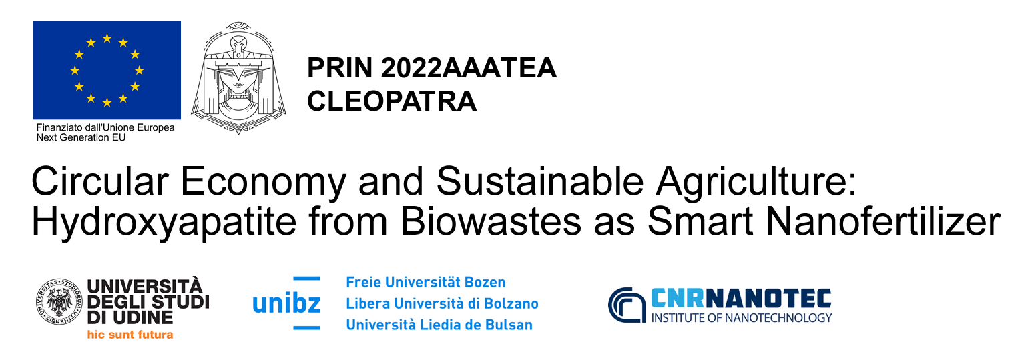

Figure 2: Logo of the project PRIN 2022 Cleopatra financed by the Italian Ministry of University (Next Generation EU funds).

Recent studies have shown that nHAP – alone or combined with other elements (such as N and micronutrients) or molecules – can improve plant nutrition, protection, and yield quality when compared to traditional fertilizers. However, they produced conflicting results and positive outcomes lack mechanistic evidence. Furthermore, they have been carried out using synthetic apatite. This will be the first comprehensive investigation carried out using a nanohybrid of biological origin from circular economy chains as an innovative fertilizer. CLEOPATRA includes activities in different phases studying both the preparation and functionalization of nHAP and its effects on maize growth (model species). More specifically, the extraction of nHAP from bones of various animals will be studied, together with their functionalization of PSB and urea. Different approaches for applying nHAP to plants, as well as its effectiveness in terms of NUE, will be assessed with plant experiments carried out at the growth chamber and mesocosm scale.

* 1. Conclusions

Recent developments in nanotechnologies for agriculture require further investigation to understand their implications. However, there is a consensus regarding the vast potential of nano-agrochemicals. The development of advanced delivery systems for fertilizers and plant protection products alone offers enormous opportunities for improving the efficiency of these production factors. Implementing nano-enabled agriculture in the broader scenario of precision agriculture could lead to the next agricultural revolution.

However, these prospects can only be achieved after intense research and experimentation. The PRIN 2022 CLEOPATRA project aims to unlock some pieces of knowledge toward the full potentiality of nHAP derived from biowastes as a sustainable and effective nanofertilizer.

In conclusion, while challenges and uncertainties remain, the prospects offered by nano-enabled agriculture are undeniable. With continued research, innovation, and regulatory oversight, the realization of a more efficient, sustainable, and resilient agricultural system is within reach. Stakeholders across academia, industry, and government must collaborate to capitalize on the transformative opportunities presented by nanotechnologies in agriculture and ensure a future of food security validated by supervisory authorities such as the European Food Safety Authority and the OECD.

* 1. References

Ahmed M., Nigussie A., Addisu S., Belay B., Sato S. 2021. Valorization of animal bone into phosphorus biofertilizer: effects of animal species, thermal processing method, and production temperature on phosphorus availability. Soil Science and Plant Nutrition, 67, 4, 471-481. <https://doi.org/10.1080/00380768.2021.1945403>.

Alewell C., Ringeval B., Ballabio C., Panagos P., Borrelli P., 2020, Global phosphorus shortage will be aggravated by soil erosion. Nature Communication, 11, 4546. <https://doi.org/10.1038/s41467-020-18326-7>.

Approaching peak phosphorus. 2022. *Nature Plants.* **8**, 979. <https://doi.org/10.1038/s41477-022-01247-2>.

Behl T. Kaur I., Sehgal A., Singh S., Sharma N., Bhatia A., Al-Harrasi A., Bungau S. 2022. The dichotomy of nanotechnology as the cutting edge of agriculture: Nano-farming as an asset versus nanotoxicity. Chemosphere, 288, 132533. <https://doi.org/10.1016/j.chemosphere.2021.132533>.

Carmona F.J., Dal Sasso G., Ramírez-Rodríguez G.B., Pii Y., Delgado-López J.M., Guagliardi A., Masciocchi N. 2021. Urea-functionalized amorphous calcium phosphate nanofertilizers: optimizing the synthetic strategy towards environmental sustainability and manufacturing costs. Scientific Reports. 11, 3419. <https://doi.org/10.1038/s41598-021-83048-9>.

Dorozhkin S.V., Epple M. 2002. Biological and medical significance of calcium phosphates. Angewandte Chemie International 41, 17, 3071-3296. [http://doi.org/10.1002/1521-3773(20020902)41:17<3130::AID-ANIE3130>3.0.CO;2-1](http://doi.org/10.1002/1521-3773(20020902)41:17%3c3130::AID-ANIE3130%3e3.0.CO;2-1).

FAO. 2021. Emissions due to agriculture. Global, regional, and country trends 2000–2018. https://www.fao.org/policysupport/tools-and-publications/resources-details/en/c/1382716

Fellet G., Pilotto L., Marchiol L, Braidot E. 2021. Tools for Nano-Enabled Agriculture: Fertilizers Based on Calcium Phosphate, Silicon, and Chitosan Nanostructures. Agronomy, 11, 1239. <https://doi.org/10.3390/agronomy11061239>.

Gollin D., Worm H.C, Asger Mose W. 2021. Two Blades of Grass: The Impact of the Green Revolution. Journal of Political Economy, 129, 8, 2344–2384. <https://doi.org/10.1086/714444>.

Hawkesford MJ, Kopriva S, De Kok LJ. (Eds). 2014. Nutrient Use Efficiency in Plants. Concepts and Approaches. Springer Cham. <https://doi.org/10.1007/978-3-319-10635-9>.

Kah M., Tufenkji N., White JC. 2019. Nano-enabled strategies to enhance crop nutrition and protection. Nat. Nanotechnol. 14, 532-540. <https://doi.org/10.1038/s41565-019-0439-5>.

Kanter D.R., Bartolini F., Kugelberg S., Leip A., Oenema O., Uwizeye A. 2020, Nitrogen pollution policy beyond the farm. Nature Food, 1, 27-32. <https://doi.org/10.1038/s43016-019-0001-5>.

Ma C., Li Q., Jia W., Shang H., Zhao J., Hao Y., Li C., Tomko M., Zuverza-Mena N., Elmer W., White J.C., Xing B. 2021. Role of nanoscale hydroxyapatite in disease suppression of Fusarium-infected tomato. Environmental Science and Technology, 55, 20, 13465-13476. <https://doi.org/10.1021/acs.est.1c00901>.

Martinon T.L.M. 2023. The urgent recognition of phosphate resource scarcity and pollution. RSC Sustain. 1, 1594-1598. <https://doi.org/10.1039/D3SU90040A>.

Maschmeyer T., Luque R., Maurizio Selva M. 2020. Upgrading of marine (fish and crustaceans) biowaste for high added-value molecules and bio(nano)-materials. Chemical Society Review. 49, 4527. <https://doi.org/10.1039/C9CS00653B>.

Mohd Pu'ad N.A.S., Koshy P., Abdullah H.Z., Idris M.I., Lee T.C. 2019. Syntheses of hydroxyapatite from natural sources. Heliyon, 5, 5, e01588. <https://doi.org/10.1016/j.heliyon.2019.e01588>.

Monroy Miguel et al. 2020. Screening bacterial phosphate solubilization with bulk-tricalcium phosphate and hydroxyapatite nanoparticles. Antonie van Leeuwenhoek (2020) 113:1033–1047. <https://doi.org/10.1007/s10482-020-01409-2>.

Mullen A. 2019. Expectations from nano in agriculture. Nature Nanotechnology. 14, 515-516. <https://doi.org/10.1038/s41565-019-0471-5>.

OECD/FAO. 2020. OECD-FAO Agricultural Outlook 2022029. Paris/FAO, Rome, <https://org.doi:10.1787/1112c23b-en>.

Priyam A., Yadav N., Reddy P.M., Afonso L.O.B., Schultz A.G., Singh P.P. 2022a. Fertilizing benefits of biogenic phosphorous nanonutrients on *Solanum lycopersicum* in soils with variable pH. Heliyon, 8, 3, e09144. <http://doi.org/10.1016/j.heliyon.2022.e09144>.

Priyam A., Yadav N., Reddy P.M., Afonso L.O.B., Schultz A.G., Singh P.P. 2022b. Uptake and benefits of biogenic phosphorus nanomaterials applied via fertigation to Japonica rice (Taipei 309) in low- and high-calcareous soil conditions. ACS Agricultural Science and Technology, 2, 3, 462-476. <https://doi.org/10.1021/acsagscitech.1c00244>.

Ramírez-Rodríguez G.B., Miguel-Rojas C., Montanha G.S., Carmona F.J., Dal Sasso G., Sillero J.C., Skov Pedersen J., Masciocchi N., Guagliardi A., Pérez-de-Luque A., Delgado-López J.M. 2020. Reducing nitrogen dosage in *Triticum durum* plants with urea-doped nanofertilizers. Nanomaterials 10, 1043. <https://doi.org/10.3390/nano10061043>.

Sigmon L.R., Vaidya S.R., Thrasher C., Mahad S., Dimkpa C.O., Elmer W., White J.C., Fairbrother D.H. 2023. Role of phosphorus type and biodegradable polymer on phosphorus fate and efficacy in a plant-soil system. Journal of Agricultural and Food Chemistry, 71, 44, 16493-16503. <http://doi.org/10.1021/acs.jafc.3c04735>.

Smith A.M., Gilbertson L.M. 2018, Rational ligand design to improve agrochemical delivery efficiency and advance agriculture sustainability. ACS Sustainable Chemical Engineering, 6, 11, 13599-13610. <https://doi.org/10.1021/acssuschemeng.8b03457>.

Springmann M., Clark M., Mason-D'Croz D, Wiebe K., Bodirsky B.L., Lassaletta L., de Vries W., Vermeulen S.J., Herrero M, Carlson K.M., Jonell M., Troell M., DeClerck F., Gordon L.J., Zurayk R., Scarborough P., Rayner M., Loken B., Fanzo J., Godfray H.C.J., Tilman D., Rockström J., Willett W. 2018. Options for keeping the food system within environmental limits. Nature, 562, 519-525. <https://doi.org/10.1038/s41586-018-0594-0>.

Szameitat A.E., Sharma A., Minutello F., Pinna A., Er-Rafik M., Hansen T.H., Persson D.P., Andersen B., Husted S. Unravelling the interactions between nano-hydroxyapatite and the roots of phosphorus deficient barley plants. Environmental Science: Nano 8, 2, 444-459. <https://doi.org/10.1039/D0EN00974A>.

Tang S., Liang J., Li O., Shao N., Jin Y., Ni J., Fei X., Li Z. Morphology-tailored hydroxyapatite nanocarrier for rhizosphere-targeted phosphorus delivery. 2023. Small, 19, 14, 2206954. <http://doi.org/10.1002/smll.202206954>.

Taskin M.B., Sahin O., Taskin, H., Atakol O., Inal A., Gunes A. Effect of synthetic nano-hydroxyapatite as an alternative phosphorus source on growth and phosphorus nutrition of lettuce (*Lactuca sativa* L.) plant. Journal of Plant Nutrition. 41, 9, 1148-1154. <https://doi.org/10.1080/01904167.2018.1433836>.

United Nations (2018). The 2030 Agenda and the Sustainable Development Goals: An opportunity for Latin America and the Caribbean (LC/G.2681-P/Rev).

Urso J.H., Gilbertson LM. 2018. Atom conversion efficiency: a new sustainability metric applied to nitrogen and phosphorus use in agriculture. ACS Sustainable Chemistry & Engineering, 6, 4453-4463. <https://doi.org/10.1021/acssuschemeng.7b03600>.

Usman M., Farooq M., Wakeel A., Nawaz A., Cheema S.A., ur Rehman H., Ashraf I., Sanaullah M., 2020. Nanotechnology in agriculture: Current status, challenges and future opportunities. Science of The Total Environment, 721, 137778. <https://doi.org/10.1016/j.scitotenv.2020.137778>.

World Bank. 2023. World Development Indicators. Agriculture, forestry, and fishing, value added (% of GDP). Retrieved from <https://data.worldbank.org/indicator/NV.AGR.TOTL.ZS>.

Yu H., Wu X., Zhang G., Zhou F., Harvey P.R., Wang L., Fan S., Xie X., Li F., Zhou H., Zhao X., Zhang X. 2022. Identification of the phosphorus-solubilizing bacteria strain JP233 and its effects on soil phosphorus leaching loss and crop growth. Frontiers in Microbiology. 13, 892533. <https://doi.org/10.3389/fmicb.2022.892533>.